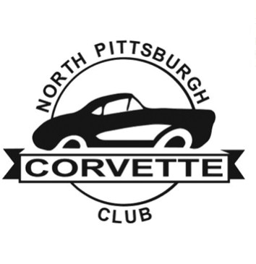
North Pittsburgh Corvette Club
2023 Membership Application

Please complete all areas and print clearly ☐New Membership ☐Renewal ☐Over 70

Member (1) Name Enter Member Name Birth Date Enter birth date
Member (2) Name Enter Member Name Birth Date Enter birth date
Mailing Address: Enter mailing address
City, State, Zip: Enter city, state and zip
Phone No.: Enter phone number Fax No.: Enter fax number
Cell No.: Enter cell number Cell No.: Enter cell number
Email address: Enter email address Email address: Enter email address
Wedding Anniversary Date if Applicable: Enter wedding anniversary
Occupation: Enter occupation Occupation: Enter occupation

MONTHLY NEWSLETTER will be distributed by email: ☐ US Mail (Black / White) add $11.00

CORVETTE INFORMATION
Year | Model  (Coupe Or Convertible) | Other Information
MEMBERSHIP TERM
January 1—December 31, 2023
Annual Dues | Single Member | Dual Members
New Membership | $30.00 | $35.00
Renewal * | $20.00 | $25.00
Dues Are Non-Refundable
Checks will not be cashed until Board approves and accepts membership.
*Renewal must be paid by Jan31, 2023
I hereby release the NORTH PITTSBURGH CORVETTE CLUB, INC, its membership and representatives, from any and all liabilities and claims occasioned by or resulting from and during our membership and any activities therewith. I hereby state that the license and insurance on my Corvette(s) is in force. I agree that, if accepted, I will abide by the By-Laws of
Signature / Enter Name: Click or tap here to enter text. Date: Click or tap to enter a date.
Signature / Enter name: Click or tap here to enter text. Date: Click or tap to enter a date.
Please mail this form with your check payable to: WEB SITE: www.np-cc.com

NORTH PITTSBURGH CORVETTE CLUB, INC., 58 Bel Aire Dr. Delmont, PA 15626

For Board Use Only
Date Received | Amount Received:
Check Number | Approved by:

